**1. Exercise :** *4*  **2. Date :** *29th October, 2020*

**3. Title :** Orthographic multi-view projections - lines and planes inclined to both the planes.

**4. Aim :** To draw the orthographic projections of straight lines and planes inclined to both the planes.

**5. Software used** : *AutoDesk AUTOCAD 2021.*

**6. Introduction :**

**i. About Orthographic projection of lines inclined to both the planes:**

*A line is defined as a line of points that extends infinitely in two directions. It*

*has one dimension, length. Line can be projected in space using T.V., F.V. &*

*S.V.*

**ii. Projection of planes inclined to both the planes:**

*A plane is a two-dimensional object having length and breadth only. Its*

*thickness is always neglected. Various shapes of plane figures are*

*considered such as square, rectangle, circle, pentagon, hexagon, etc. Projection of planes mainly includes its projection on T.V., F.V. & S.V.*

**7. Procedure** (for solving question):

**7.1** Question Outline : *To understand the fundamentals of projection of lines.*

**7.2** Object : *Projections of lines, Lines inclined to both lines, etc.*

**7.3** Conditions (if any) : *All dimensions should be in millimeters (mm).*

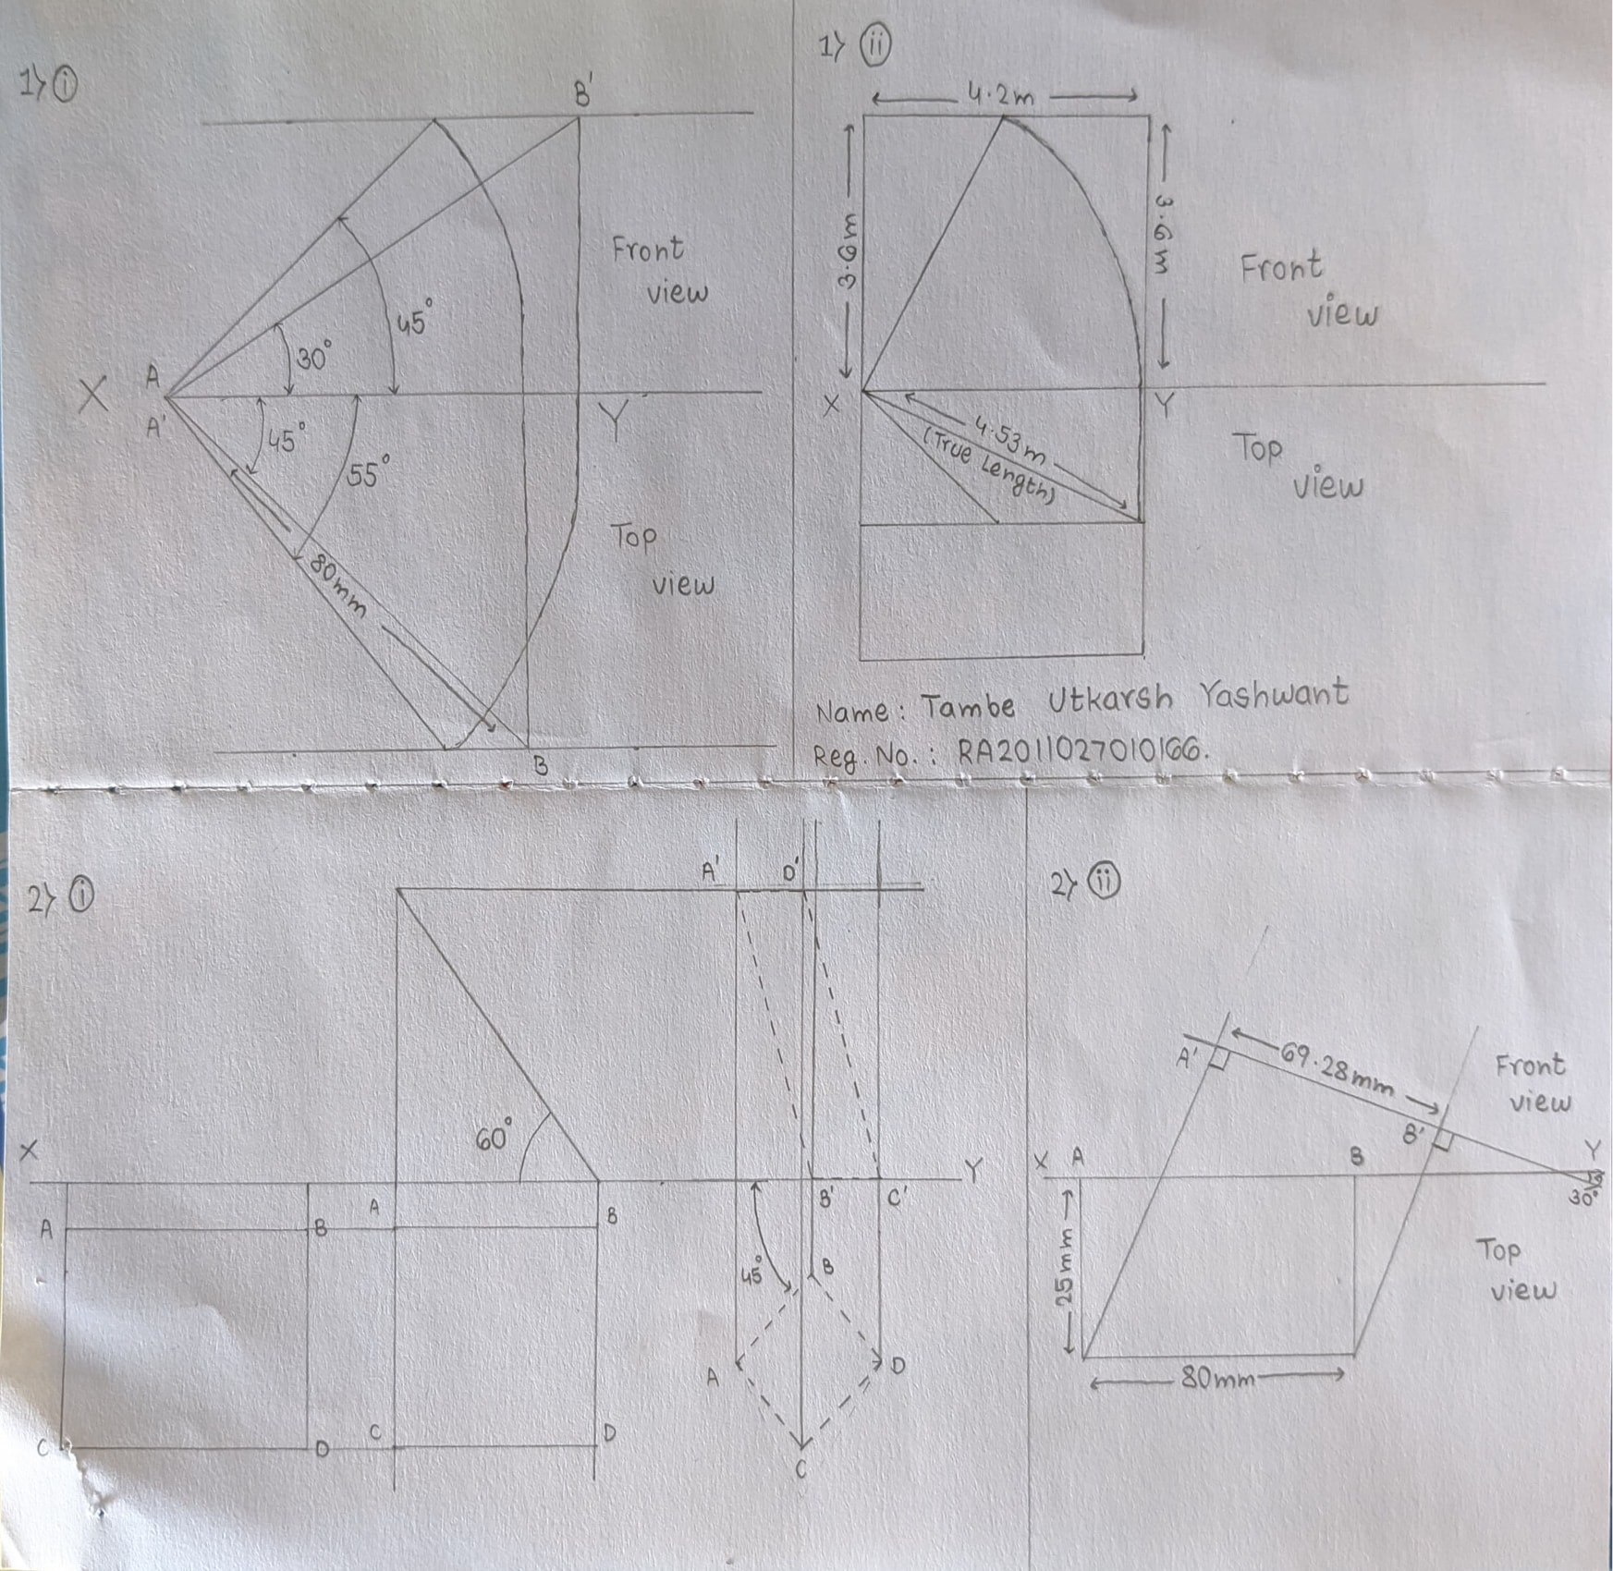

**Fig.: Free hand sketch of the solution to question**

**7.4** Drawing Procedure :

**Step 1. *Setting up the workspace :-***

* 1. *Set the units and precision we are going to work with using* ***“UNITS”*** *command, here we will keep precision to be 1unit place (0) and unit as millimeter.*
  2. *Then, set the workable area using* ***“LIMITS”*** *command to area of (297mm) x (210mm) by specifying origin or lower left corner as (0, 0) and upper right corner as (297, 210).*
  3. *Finally, use the command* ***“ZOOM”*** *with the* ***“all”*** *attribute to expand the work area to the entire screen.*
  4. *Use the command* ***“LINE”*** *to make XY axis.*

**Step 2. *Projection of lines inclined to both the planes (without traces) :-***

* 1. *Make 80 mm line with* ***“LINE”*** *command with x as vertex inclined with an angle of 30° and mark it* ***A’, B’*** *respectively and highlight the line.*
  2. *Draw a line parallel to the axis along* ***B’.***
  3. *Make another 80 mm Line with* ***“LINE”*** *command with x as vertex downwards with an angle of 45° and mark it A, B respectively and highlight the line.*
  4. *Drop a perpendicular line from* ***B’*** *and* ***B*** *to the axis.*
  5. *Draw a circle with A as center to the foot of the perpendicular drawn from* ***B’*** *and trim of the outside parts.*
  6. *Draw a line using* ***“LINE”*** *command from* ***A*** *to the intersection of the arc of the circle and line parallel to the axis and highlight the line in green color.*
  7. *Repeat the same procedure as point (v) and (vi) but with the foot of the perpendicular drawn from* ***B*** *to the axis.*

**Step 3. *True length and true inclinations of the line :-***

* 1. *Make a 4.2m × 3.6m rectangle above & below the XY axis.*
  2. *Draw a line from the point where the axis & 3.6m side intersect each other. Name this point as A, to the midpoint of 4.2m side name this point as B & so the line is AB which is situated above the XY axis. Now below the XY axis, draw a line joining the midpoints of both the sides measuring 3.6m in breadth.*
  3. *Similarly, again join the points by drawing a line from the point A as mentioned above to the midpoint of the line drawn before, below the XY axis. All the lines drawn till now are drawn using the* ***“LINE”*** *command.*
  4. *Now, draw a circle with center A and stretch it up to point B using* ***“CIRCLE”*** *command. Trim the remaining part of the circle using* ***“TRIM”*** *command which lies outside the rectangular region drawn.*
  5. *Focus on the untrimmed part, draw a line using the* ***“LINE”*** *command again from the endpoint of the untrimmed circle to the line drawn below the axis as mentioned in point (ii) and name that point as C.*
  6. *Finally, draw a line from point A to point C and name it as (True Length) using the* ***“TEXT”*** *command.*
  7. *Using* ***“TEXT”*** *command only, name the necessary terms if required (i.e. Front view, Top view, etc.).*

**Step 4. *Projection of planes inclined to both the planes :-***

* 1. *Make a 70mm x 30 mm rectangle using the* ***“LINE”*** *command ABCD below the XY axis.*
  2. *Color the sides of this rectangle yellow and mark its corners A, B, C & D using the* ***“TEXT”*** *command.*
  3. *Project the above the XY axis the rectangle ABCD using the “LINE” command the same distance it is below it.*
  4. *Make a Triangle using the* ***“LINE”*** *command with hypotenuse of 70 mm, 35 mm from the rightmost edge of the projected line.*
  5. *Color the sides of this triangle yellow.*
  6. *Project two lines from the base of the triangle lying on the XY axis using the* ***“LINE”*** *command.*
  7. *Similarly project 2 lines using the* ***“LINE”*** *command parallel to sides AB and CD from the right side of the rectangle.*
  8. *The four lines intersect to form a rectangle of side 35mm x 30 mm.*
  9. *Color the sides of this rectangle yellow.*
  10. *Trim the ends of the unnecessary lines.*

**Step 5.** ***Auxiliary Projection :-***

* 1. *Use the command* ***“LINE”*** *to make a line 25 mm long vertically downwards. Use the command* ***“TEXT”*** *to name the endpoint as* ***A****.*
  2. *From* ***A*** *draw a line 80 mm long at an angle of 30° from the axis. Name the endpoint as* ***B****. Highlight the line.*
  3. *From points* ***A*** *and* ***B****, drop perpendiculars on the axis. Mark the intersection points as* ***A’*** *and* ***B’****.*
  4. *Draw a line from* ***A’*** *to* ***B’****. Highlight the line.*
  5. *Line* ***AB*** *is the required Top View and* ***A’B’*** *is the required Front View.*

**Step 6. *Annotations :-***

* 1. *Using the command* ***“DIM”*** *and appropriate attributes mark all the dimensions taken in the experiment.*



**8. Commands Used :**

|  |  |  |
| --- | --- | --- |
| *Sr. No.* | *Command* | *Use* |
| ***1.*** | *UNITS* | *Used to set unit type and precision.* |
| ***2.*** | *LIMITS* | *Define the workspace and give it a boundary.* |
| ***3.*** | *ZOOM* | *Expand/contract the work area to visible screen.* |
| ***4.*** | *LINE* | *Used to draw line.* |
| ***5.*** | *DIMSTYLE* | *Used change the look of the Dimensions* |
| ***6.*** | *STYLE* | *Used to change the way the text looks* |
| ***7.*** | *TEXT* | *To write TEXT at the specified location.* |
| ***8.*** | *CIRCLE* | *Used to draw circle of preferred size.* |
| ***9.*** | *TRIM* | *Used to remove/erase any undesired line.* |
| ***10.*** | *DIM* | *Used to write the dimension of the objects.* |

**9. Result :**

*Thus, by the use of AutoCAD 2021 we are able to draw the lines respective to given length and also their projections. True length of the lines can also be determined.*

|  |  |  |  |
| --- | --- | --- | --- |
| **Faculty Name** |  | **Date of Submission** |  |
| **Signature** |  | **Marks** |  |